Для размещения баннера платформы обратной связи на сайте Госуслуг необходимо (для сайтов Ucoz):

**- зайти на сайт в роли администратора**

**- выбрать вкладку «управление дизайном»**

**- включить конструктор** **сайта**



**- добавить блок и перенести его в верхнюю часть сайта** (чтобы при просмотре сайта виджет ПОС был наверху, без прокрутки)



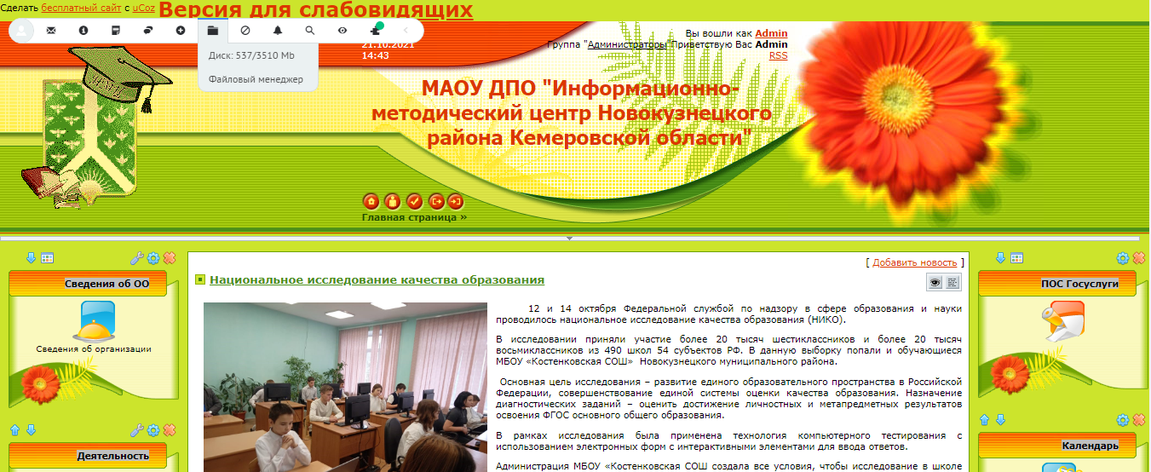

- **нажать на значок «настройки»**, **в открывшемся окне выбрать вкладку «HTML», добавить код**

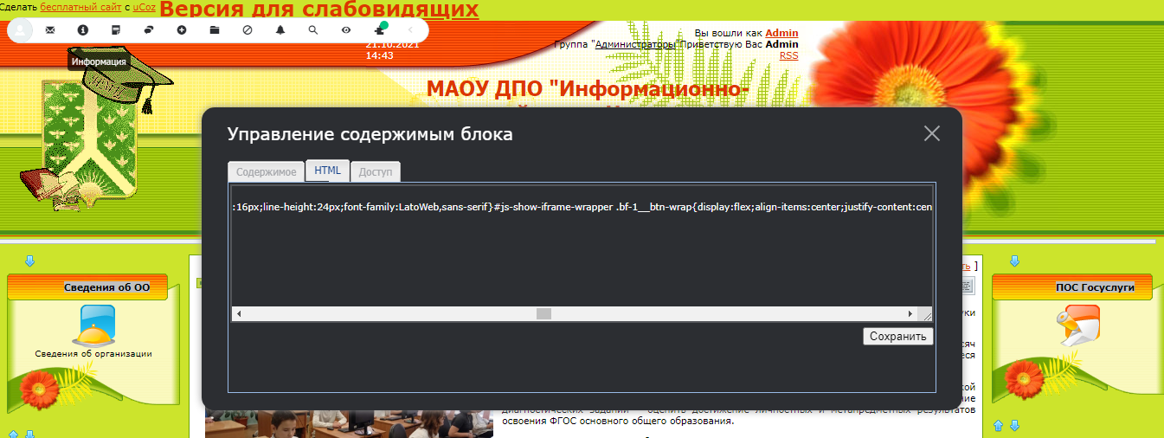

<!-- <a href="https://vk.com/marafon_nkmr" target="_blank" style = "color:#FF0000; font-size: 10pt; font-weight: bold"></a> -->

<script src='https://pos.gosuslugi.ru/bin/script.min.js'></script> <style> @charset "UTF-8";#js-show-iframe-wrapper{position:relative;display:flex;align-items:center;justify-content:center;width:100%;min-width:293px;max-width:100%;background:linear-gradient(138.4deg,#38bafe 26.49%,#2d73bc 79.45%);color:#fff; cursor: pointer;}#js-show-iframe-wrapper .pos-banner-fluid *{box-sizing:border-box}#js-show-iframe-wrapper .pos-banner-fluid .pos-banner-btn_2{display:block;width:195px;min-height:56px;font-size:18px;line-height:24px;cursor:pointer;background:#0d4cd3;color:#fff;border:none;border-radius:8px;outline:0}#js-show-iframe-wrapper .pos-banner-fluid .pos-banner-btn_2:hover{background:#1d5deb}#js-show-iframe-wrapper .pos-banner-fluid .pos-banner-btn_2:focus{background:#2a63ad}#js-show-iframe-wrapper .pos-banner-fluid .pos-banner-btn_2:active{background:#2a63ad}@-webkit-keyframes fadeInFromNone{0%{display:none;opacity:0}1%{display:block;opacity:0}100%{display:block;opacity:1}}@keyframes fadeInFromNone{0%{display:none;opacity:0}1%{display:block;opacity:0}100%{display:block;opacity:1}}@font-face{font-family:LatoWebLight;src:url(https://pos.gosuslugi.ru/bin/fonts/Lato/fonts/Lato-Light.woff2) format("woff2"),url(https://pos.gosuslugi.ru/bin/fonts/Lato/fonts/Lato-Light.woff) format("woff"),url(https://pos.gosuslugi.ru/bin/fonts/Lato/fonts/Lato-Light.ttf) format("truetype");font-style:normal;font-weight:400;text-rendering:optimizeLegibility}@font-face{font-family:LatoWeb;src:url(https://pos.gosuslugi.ru/bin/fonts/Lato/fonts/Lato-Regular.woff2) format("woff2"),url(https://pos.gosuslugi.ru/bin/fonts/Lato/fonts/Lato-Regular.woff) format("woff"),url(https://pos.gosuslugi.ru/bin/fonts/Lato/fonts/Lato-Regular.ttf) format("truetype");font-style:normal;font-weight:400;text-rendering:optimizeLegibility}@font-face{font-family:LatoWebBold;src:url(https://pos.gosuslugi.ru/bin/fonts/Lato/fonts/Lato-Bold.woff2) format("woff2"),url(https://pos.gosuslugi.ru/bin/fonts/Lato/fonts/Lato-Bold.woff) format("woff"),url(https://pos.gosuslugi.ru/bin/fonts/Lato/fonts/Lato-Bold.ttf) format("truetype");font-style:normal;font-weight:400;text-rendering:optimizeLegibility} </style> <style> #js-show-iframe-wrapper .bf-1{position:relative;display:grid;grid-template-columns:var(--pos-banner-fluid-1__grid-template-columns);grid-template-rows:var(--pos-banner-fluid-1__grid-template-rows);width:100%;max-width:1060px;font-family:LatoWeb,sans-serif;box-sizing:border-box}#js-show-iframe-wrapper .bf-1__decor{grid-column:var(--pos-banner-fluid-1__decor-grid-column);grid-row:var(--pos-banner-fluid-1__decor-grid-row);padding:var(--pos-banner-fluid-1__decor-padding);background:url(https://pos.gosuslugi.ru/bin/banner-fluid/1/banner-fluid-bg-1.svg) var(--pos-banner-fluid-1__decor-bg-position) no-repeat;background-size:var(--pos-banner-fluid-1__decor-bg-size)}#js-show-iframe-wrapper .bf-1__logo-wrap{display:flex;flex-direction:column;align-items:flex-end}#js-show-iframe-wrapper .bf-1__logo{width:128px}#js-show-iframe-wrapper .bf-1__slogan{font-family:LatoWebBold,sans-serif;font-size:var(--pos-banner-fluid-1__slogan-font-size);line-height:var(--pos-banner-fluid-1__slogan-line-height)}#js-show-iframe-wrapper .bf-1__content{padding:var(--pos-banner-fluid-1__content-padding)}#js-show-iframe-wrapper .bf-1__description{display:flex;flex-direction:column;margin-bottom:24px}#js-show-iframe-wrapper .bf-1__text{margin-bottom:12px;font-size:24px;line-height:32px;font-family:LatoWebBold,sans-serif}#js-show-iframe-wrapper .bf-1__text_small{margin-bottom:0;font-size:16px;line-height:24px;font-family:LatoWeb,sans-serif}#js-show-iframe-wrapper .bf-1__btn-wrap{display:flex;align-items:center;justify-content:center} </style > <div id='js-show-iframe-wrapper'> <div class='pos-banner-fluid bf-1'> <div class='bf-1__decor'> <div class='bf-1__logo-wrap'> <img class='bf-1__logo' src='https://pos.gosuslugi.ru/bin/banner-fluid/gosuslugi-logo.svg' alt='Госуслуги' /> <div class='bf-1__slogan'>Жалобы на всё</div > </div > </div > <div class='bf-1__content'> <div class='bf-1__description'> <span class='bf-1__text'> Не убран снег, яма на дороге, не горит фонарь? </span > <span class='pos-banner-fluid__text pos-banner-fluid__text_small'> Столкнулись с проблемой&nbsp;— сообщите о ней! </span > </div > <div class='bf-1__btn-wrap'> <!-- pos-banner-btn_2 не удалять; другие классы не добавлять --> <button class='pos-banner-btn_2' type='button' >Подать жалобу </button > </div > </div > </div > </div > <script> "use strict";var root=document.documentElement,banner=document.getElementById("js-show-iframe-wrapper");function displayWindowSize(){var e=banner.offsetWidth;e<=500&&(root.style.setProperty("--pos-banner-fluid-1__grid-template-columns","100%"),root.style.setProperty("--pos-banner-fluid-1__grid-template-rows","310px auto"),root.style.setProperty("--pos-banner-fluid-1__decor-grid-column","initial"),root.style.setProperty("--pos-banner-fluid-1__decor-grid-row","initial"),root.style.setProperty("--pos-banner-fluid-1__decor-padding","30px 30px 0 30px"),root.style.setProperty("--pos-banner-fluid-1__decor-bg-position","center calc(100% - 10px)"),root.style.setProperty("--pos-banner-fluid-1__decor-bg-size","75% 75%"),root.style.setProperty("--pos-banner-fluid-1__content-padding","0 30px 30px 30px"),root.style.setProperty("--pos-banner-fluid-1__slogan-font-size","24px"),root.style.setProperty("--pos-banner-fluid-1__slogan-line-height","32px")),e>500&&e<=800&&(root.style.setProperty("--pos-banner-fluid-1__grid-template-columns","min-content 1fr"),root.style.setProperty("--pos-banner-fluid-1__grid-template-rows","100%"),root.style.setProperty("--pos-banner-fluid-1__decor-grid-column","2"),root.style.setProperty("--pos-banner-fluid-1__decor-grid-row","1"),root.style.setProperty("--pos-banner-fluid-1__decor-padding","30px 30px 30px 0"),root.style.setProperty("--pos-banner-fluid-1__decor-bg-position","calc(30% - 10px) calc(72% - 2px)"),root.style.setProperty("--pos-banner-fluid-1__decor-bg-size","calc(23% + 150px)"),root.style.setProperty("--pos-banner-fluid-1__content-padding","30px"),root.style.setProperty("--pos-banner-fluid-1__slogan-font-size","24px"),root.style.setProperty("--pos-banner-fluid-1__slogan-line-height","32px")),e>800&&e<=1020&&(root.style.setProperty("--pos-banner-fluid-1__grid-template-columns","min-content 1fr"),root.style.setProperty("--pos-banner-fluid-1__grid-template-rows","100%"),root.style.setProperty("--pos-banner-fluid-1__decor-grid-column","2"),root.style.setProperty("--pos-banner-fluid-1__decor-grid-row","1"),root.style.setProperty("--pos-banner-fluid-1__decor-padding","30px 30px 30px 0"),root.style.setProperty("--pos-banner-fluid-1__decor-bg-position","calc(38% - 50px) calc(6% - 0px)"),root.style.setProperty("--pos-banner-fluid-1__decor-bg-size","420px"),root.style.setProperty("--pos-banner-fluid-1__content-padding","30px"),root.style.setProperty("--pos-banner-fluid-1__slogan-font-size","32px"),root.style.setProperty("--pos-banner-fluid-1__slogan-line-height","40px")),e>1020&&(root.style.setProperty("--pos-banner-fluid-1__grid-template-columns","min-content 1fr"),root.style.setProperty("--pos-banner-fluid-1__grid-template-rows","100%"),root.style.setProperty("--pos-banner-fluid-1__decor-grid-column","2"),root.style.setProperty("--pos-banner-fluid-1__decor-grid-row","1"),root.style.setProperty("--pos-banner-fluid-1__decor-padding","30px 30px 30px 0"),root.style.setProperty("--pos-banner-fluid-1__decor-bg-position","calc(30% - 28px) calc(0% - 40px)"),root.style.setProperty("--pos-banner-fluid-1__decor-bg-size","620px"),root.style.setProperty("--pos-banner-fluid-1__content-padding","30px"),root.style.setProperty("--pos-banner-fluid-1__slogan-font-size","32px"),root.style.setProperty("--pos-banner-fluid-1__slogan-line-height","40px"))}displayWindowSize();var resizeListener=window.addEventListener("resize",displayWindowSize);window.onunload=function(){window.removeEventListener("resize",resizeListener)}; </script> <script>Widget("https://pos.gosuslugi.ru/form", 215808)</script>

**нажать «сохранить»**

**во вкладке «управление дизайном» нажать «сохранить изменения»**



**Отключить конструктор**